**Report on HIV/AIDS Red Club Ravage Program**

**Event**: HIV/AIDS Red Club Ravage Program  
**Date**: 30th July 2024  
**Location**: Indraprastha New Arts, Commerce, and Science College, Wardha

**Chief Guests**:

* Dr. Ashish Sasankar, Principal
* Prof. Sandip Petare, IQAC Coordinator
* Dr. Madan Ingale, Sports Coordinator

**Overview**: The HIV/AIDS Red Club Ravage Program was organized by Civil Hospital Wardha at Indraprastha New Arts, Commerce, and Science College, Wardha, on 30th July 2024. The event aimed to raise awareness about HIV/AIDS and engage students in informative and interactive activities. The program was well-attended and featured various competitions to encourage student participation and enthusiasm.

**Competitions**:

1. **Quiz Competition**:
   * The quiz focused on HIV/AIDS awareness, prevention, and treatment.
   * Students demonstrated significant knowledge and understanding of the subject.
2. **Racing Competition**:
   * The racing event was organized to promote physical fitness and teamwork while integrating HIV/AIDS awareness themes.

**Results**:

* **CS Department Achievements**:
  + Students from the Computer Science (CS) Department excelled in both competitions.
  + They were awarded cash prizes, medals and certificates for their impressive performances in the quiz and racing events.

|  |  |  |  |  |
| --- | --- | --- | --- | --- |
| **Sr. No.** | **Name of Student** | **Class** | **Medal** | **Cash** |
| **1** | Khushbu Mhatre | B.Sc 1st yr | Gold | 1500/- |
| **2** | Vedant Khandale | B.Sc 2nd yr | Gold | 1500/- |
| **3** | Kshitij Chambhare | B.Sc 1st yr | Silver | 1000/- |
| **4** | Aaryan Parshive | B.Sc 2nd yr | Bronze | 500/- |

**Special Acknowledgements**:

* **Dr. Ashish Sasankar**, the Principal, emphasized the importance of education and awareness in combating HIV/AIDS and applauded the students for their active participation.
* **Prof. Sandip Petare**, the IQAC Coordinator, highlighted the role of educational institutions in fostering awareness and supporting health initiatives.
* **Dr. Madan Ingale**, the Sports Coordinator, praised the students for their sportsmanship and enthusiasm.

The program was a success in promoting HIV/AIDS awareness and fostering a spirit of healthy competition among the students. The collaboration between the Civil Hospital Wardha and the college was instrumental in the event's success.

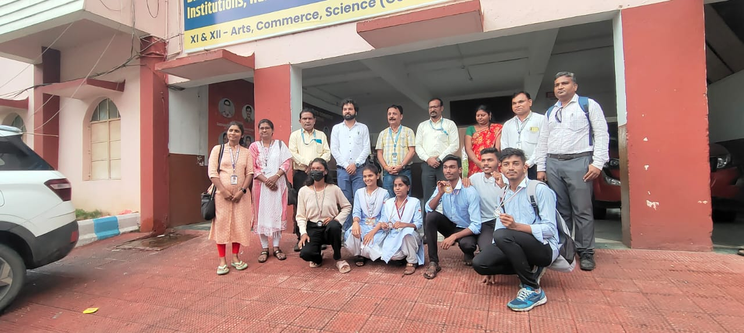**Conclusion**: The HIV/AIDS Red Club Ravage Program was an engaging and informative event, with active student participation and strong support from the college administration. The success of the program reflects the collective efforts in raising awareness and encouraging a proactive approach towards health issues.

